**DATA ANALYSIS WITH COMPLEX QUERIES**

***USING WINDOW FUNCTION:***

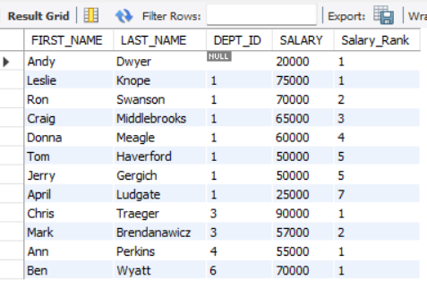

***SUBQUERY:***

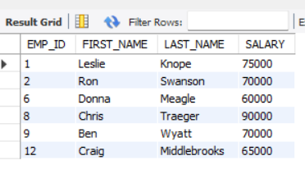

***CTES(COMMON TABLE EXPRESSIONS):***

